CSS BRITISH HISTORY · TOPIC 2 · QUESTION ANSWERS
Hanoverian Britain, the Whig Oligarchy and the First Empire (1714–1783)
Every past question on the Hanoverian succession, Walpole, the Whig oligarchy, the Jacobites, Chatham, abolition and the American War — answered in full

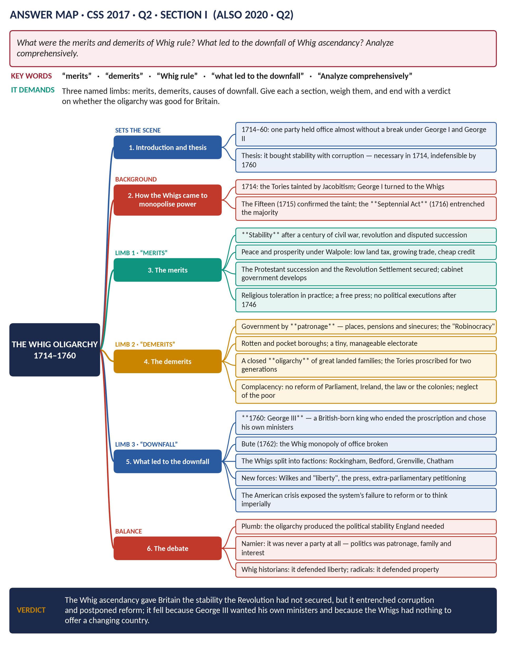
Seven full answers and one short note (2015–2026), each with its answer map, a figure and a note on why it scores; the topic's seven past MCQs solved; and five predicted questions with outlines.
Topic 2 of 10 · companion to T2KB (the Knowledge Base)
Contents
HOW TO USE THIS · Updating the contents
Right-click the contents → Update Field → Update entire table, before saving as PDF.

How to Use These Answers 6
What is in this document 6
How every answer is built 6
Answer 1 · The Hanoverian Succession and Its Significance 7
The model answer 9
(1) Introduction and thesis 9
(2) How the succession was managed 9
Political significance 9
(3) The Whig supremacy 9
(4) Jacobitism as the permanent alternative 9
(5) Politics as management 10
Constitutional significance 10
(6) A parliamentary crown 10
(7) Cabinet government 10
(8) The office of prime minister 10
(9) Ministers responsible to the Commons 10
(10) The Act of Settlement's restrictions 10
(11) The limits of the change 11
(12) Conclusion 11
Answer 2 · Walpole in Four Roles 12
The model answer 14
(1) Introduction and thesis 14
(2) Role one: minister of the Crown 14
(3) Role two: prime minister in the making 14
(4) Role three: party organiser 15
(5) Role four: financier 15
(6) The critical case against Walpole 16
(7) Assessment 16
(8) Conclusion 16
Answer 3 · The Merits, Demerits and Downfall of Whig Rule 18
The model answer 20
(1) Introduction and thesis 20
(2) How the Whigs came to monopolise power 20
(3) The merits 20
(4) The demerits 21
(5) What led to the downfall 21
(6) The historians' debate 22
(7) Conclusion 22
Answer 4 · The Same Question, Re-angled 23
How to adapt Answer 3 23
The three changes to make 23
The conclusion to use for 2020 24
Short Notes 25
The Jacobite Revolt of Scotland 25
(1) Definition 25
(2) Background 25
(3) The main events 25
(4) Why it failed 26
(5) The aftermath and significance 26
(6) Assessment 26
Answer 5 · Chatham: "A Glorious Success Until 1761 and Then Failure" 28
The model answer 30
(1) Introduction and thesis 30
(2) Before 1756: the outsider 30
Limb one — the case for "glorious success" to 1761 30
(3) He took over a losing war 30
(4) He devised a winning strategy 30
(5) The results 30
(6) He governed as a national leader 31
Limb two — the case for "then failure" 31
(7) The resignation of 1761 31
(8) The pension and the peerage 31
(9) The Peace of Paris and the lost decade 31
(10) The failed ministry of 1766–68 32
(11) Ambiguity on America 32
(12) Testing the date: why 1761? 32
(13) The qualification 32
(14) Conclusion 32
Answer 6 · Abolition, Imperialism and Economic Interests 34
The model answer 36
(1) Introduction and thesis 36
(2) The system that was abolished 36
(3) The economic argument: Eric Williams 37
(4) The humanitarian reply: Drescher and the movement 37
(5) How abolition served empire 37
(6) The argument against the proposition 38
(7) Conclusion 38
Answer 7 · The American War: The Balance Sheet for Britain 39
The model answer 41
(1) Introduction and thesis 41
(2) The war in brief 41
The debit side 42
(3) Territory and power 42
(4) Prestige and strategic position 42
(5) Money 42
(6) Politics at home and in Ireland 43
The credit side 43
(7) Trade survived the political break 43
(8) The rest of the empire was kept 43
(9) Reform at home 43
(10) A different idea of empire 43
(11) The swing to the East 43
(12) The balance 43
(13) Conclusion 44
Part Two — The Past MCQs, Solved 45
CSS 2024 · MCQ 1 45
CSS 2024 · MCQ 13 45
CSS 2025 · MCQ 3 45
CSS 2025 · MCQ 4 46
CSS 2026 · MCQ 3 46
CSS 2026 · MCQ 4 46
CSS 2026 · MCQ 14 46
Part Three — Five Predicted Questions, with Outlines 47
Predicted 1 · "Explain the Old Colonial System. Why did it break down in America?" 47
Predicted 2 · "Give an account of the Jacobite risings of 1715 and 1745. Why did they fail?" 47
Predicted 3 · "Assess the reign of George III to 1783. Did he try to subvert the constitution?" 47
Predicted 4 · "What were the causes of the American War of Independence? Could Britain have avoided it?" 47
Predicted 5 · "Evaluate Britain's role in the Atlantic slave trade and its abolition." 48

How to Use These Answers

What is in this document
# | Paper | Question (short) | Answer
1 | 2019 Q3 | Political and constitutional significance of the Hanoverian succession | Answer 1
2 | 2015 P1 Q4 | Walpole as Secretary of State, PM, party organiser and financier | Answer 2
3 | 2017 Q2 | Merits and demerits of Whig rule; the downfall of the ascendancy | Answer 3
4 | 2020 Q2 | The same question, re-angled — how to adapt Answer 3 | Answer 4
5 | 2015 P1 Q8(c) | Short note: the Jacobite Revolt of Scotland | Short note
6 | 2022 Q3 | "A glorious success until 1761 and then failure" — Chatham | Answer 5
7 | 2026 Q2 | Abolition, imperialism and economic interests | Answer 6
8 | 2015 P1 Q5 | The American War: its debit and credit side for Britain | Answer 7

The answers follow the story order of the topic, not the year order.

How every answer is built
1. The question, exactly as set. 2. The answer map — the mind map to draw in the first 90 seconds. 3. Decoding the question. 4. The model answer — numbered headings with sub-headings, a figure and a verdict, about 1,200–1,500 words. 5. Why this answer scores.
TRAP — DO NOT FALL INTO IT · Two questions, one family
2017 Q2 and 2020 Q2 ask almost the same thing about the Whig oligarchy. Answer 3 is written in full; Answer 4 shows exactly how to re-angle it for the 2020 wording. Learn one body of material and two ways of arranging it.

Answer 1 · The Hanoverian Succession and Its Significance
THE QUESTION · CSS 2019 · Q3 · Section A · 20 marks
What was the political and constitutional significance of the Hanoverian succession in England?

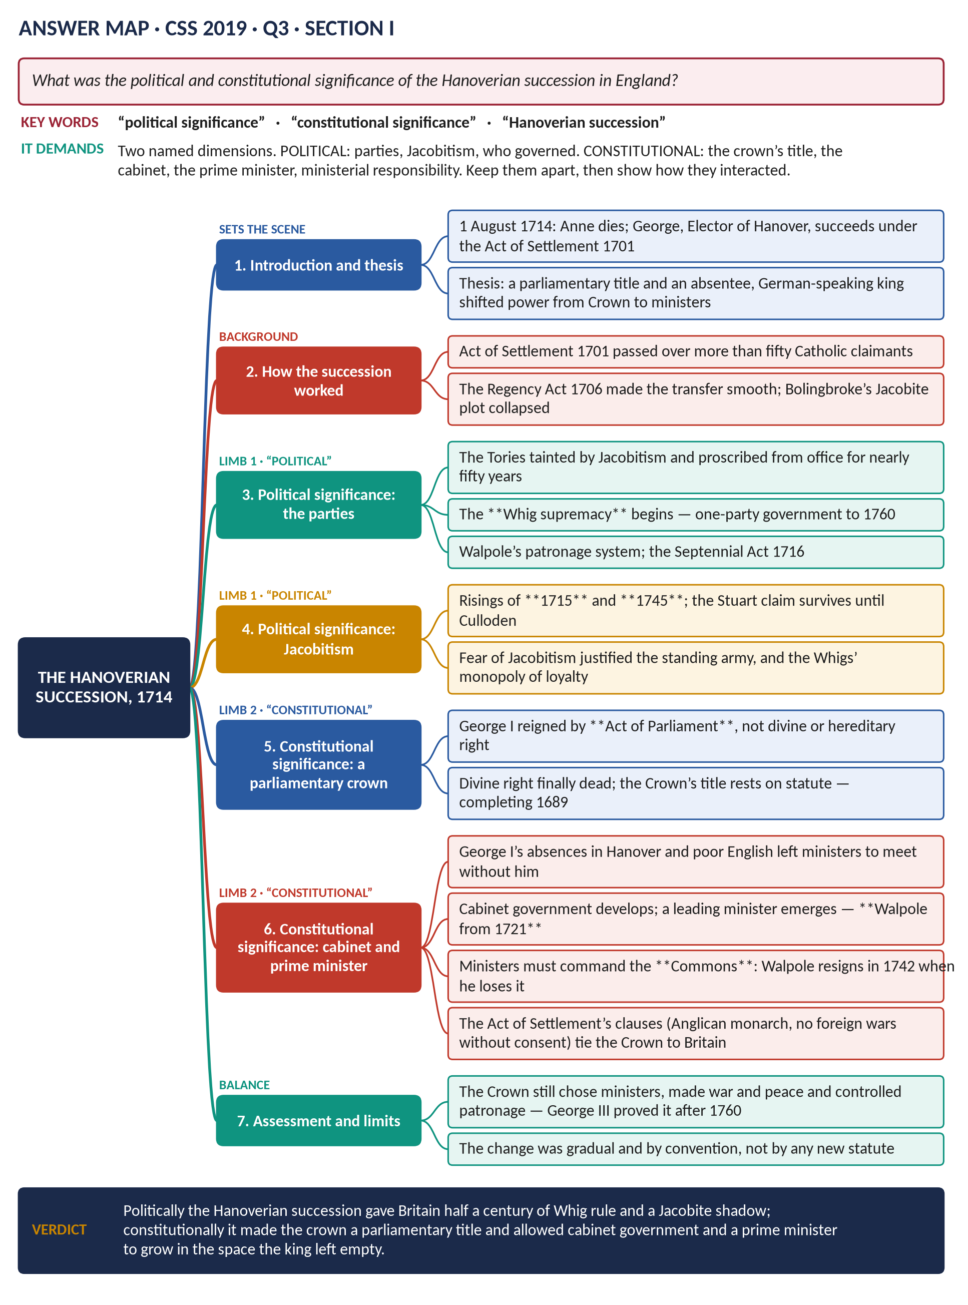
Figure 1 · The answer map for CSS 2019 · Q3 · Section A: every branch is one heading of the answer below.
DECODING THE QUESTION
Two named dimensions. Political: who governed, the fate of the parties, Jacobitism. Constitutional: the basis of the crown's title, the cabinet, the prime minister, ministerial responsibility. Keep the two apart under separate headings, then show how the political facts produced the constitutional changes. A good answer also states the limits — the Crown was still strong.

The model answer

(1) Introduction and thesis
On 1 August 1714 Queen Anne died and the crown passed, under the Act of Settlement of 1701, to George Louis, Elector of Hanover, over more than fifty Catholics with a better hereditary claim. The succession was smooth, but its consequences were profound. Politically it gave the Whigs a monopoly of office for nearly fifty years and left Jacobitism as a permanent rival. Constitutionally it confirmed that the crown was held by Act of Parliament, and — because the new kings were foreign and often absent — allowed cabinet government and the office of prime minister to grow in the space the monarch left empty.

(2) How the succession was managed
- The Act of Settlement (1701) named Sophia of Hanover and her Protestant heirs; she died in June 1714, so her son succeeded.
- The Regency Act (1706) provided named Lords Justices to govern until the new king arrived, which made the transfer orderly.
- Bolingbroke, the Tory Secretary of State, had been corresponding with the Pretender; he was dismissed and fled to France in 1715 — an act that condemned his party for a generation.

Political significance

(3) The Whig supremacy
George I owed his throne to the party that had made the Act of Settlement, and he distrusted the Tories who had made the Peace of Utrecht. He therefore gave office to the Whigs — and the Tories were proscribed, shut out of the ministry, the court, the bench and the lord-lieutenancies, until 1760. The consequence was one-party government under Walpole (1721–42) and the Pelhams, sustained by patronage and by the Septennial Act of 1716, which extended the life of a Parliament to seven years.

(4) Jacobitism as the permanent alternative
Because the Stuarts had the better hereditary claim, the Hanoverian regime faced a rival court in exile throughout the period:
- the Fifteen (1715) under the Earl of Mar, defeated at Sheriffmuir and Preston;
- the Forty-Five (1745–46), which reached Derby before ending at Culloden;
- French-backed attempts in 1708 and 1759.
Jacobitism justified the standing army, tied the Tories to treason in the public mind, and gave the Whigs a monopoly of loyalty.

(5) Politics as management
With one party in office and no ideological divide, politics became a contest of connections — Walpole's, Newcastle's, Bedford's — inside the Whig camp. As Namier argued, eighteenth-century politics is best understood through interest, family and patronage rather than programme.

Constitutional significance

(6) A parliamentary crown
George I was king because Parliament said so. After 1714 the doctrine of indefeasible hereditary right survived only among Non-Jurors and Jacobites. The Revolution principle of 1689 — that the succession is a matter of statute — was now beyond argument.

(7) Cabinet government
George I spoke little English, was deeply interested in Hanover, and spent long periods abroad. He ceased to attend cabinet regularly. Ministers therefore met, deliberated and reported. What began as convenience hardened into convention: the cabinet as a body that decides collectively and presents united advice.

(8) The office of prime minister
Someone had to lead that cabinet, manage the Commons and speak to the king. From 1721 that man was Sir Robert Walpole, who held the Treasury and the Exchequer, stayed in the Commons, and enforced cabinet unity by driving out rivals such as Townshend (1730). The title "prime minister" began as an insult; the office grew because the system needed it.

(9) Ministers responsible to the Commons
The decisive precedent came in 1742, when Walpole resigned — not because the King dismissed him, but because he had lost his majority. This is the foundation of modern parliamentary government.

(10) The Act of Settlement's restrictions
The same Act that brought the Hanoverians tied them to Britain: the monarch must be Anglican; Britain must not go to war for the monarch's foreign possessions without Parliament's consent; and judges hold office during good behaviour, removable only on an address of both Houses.
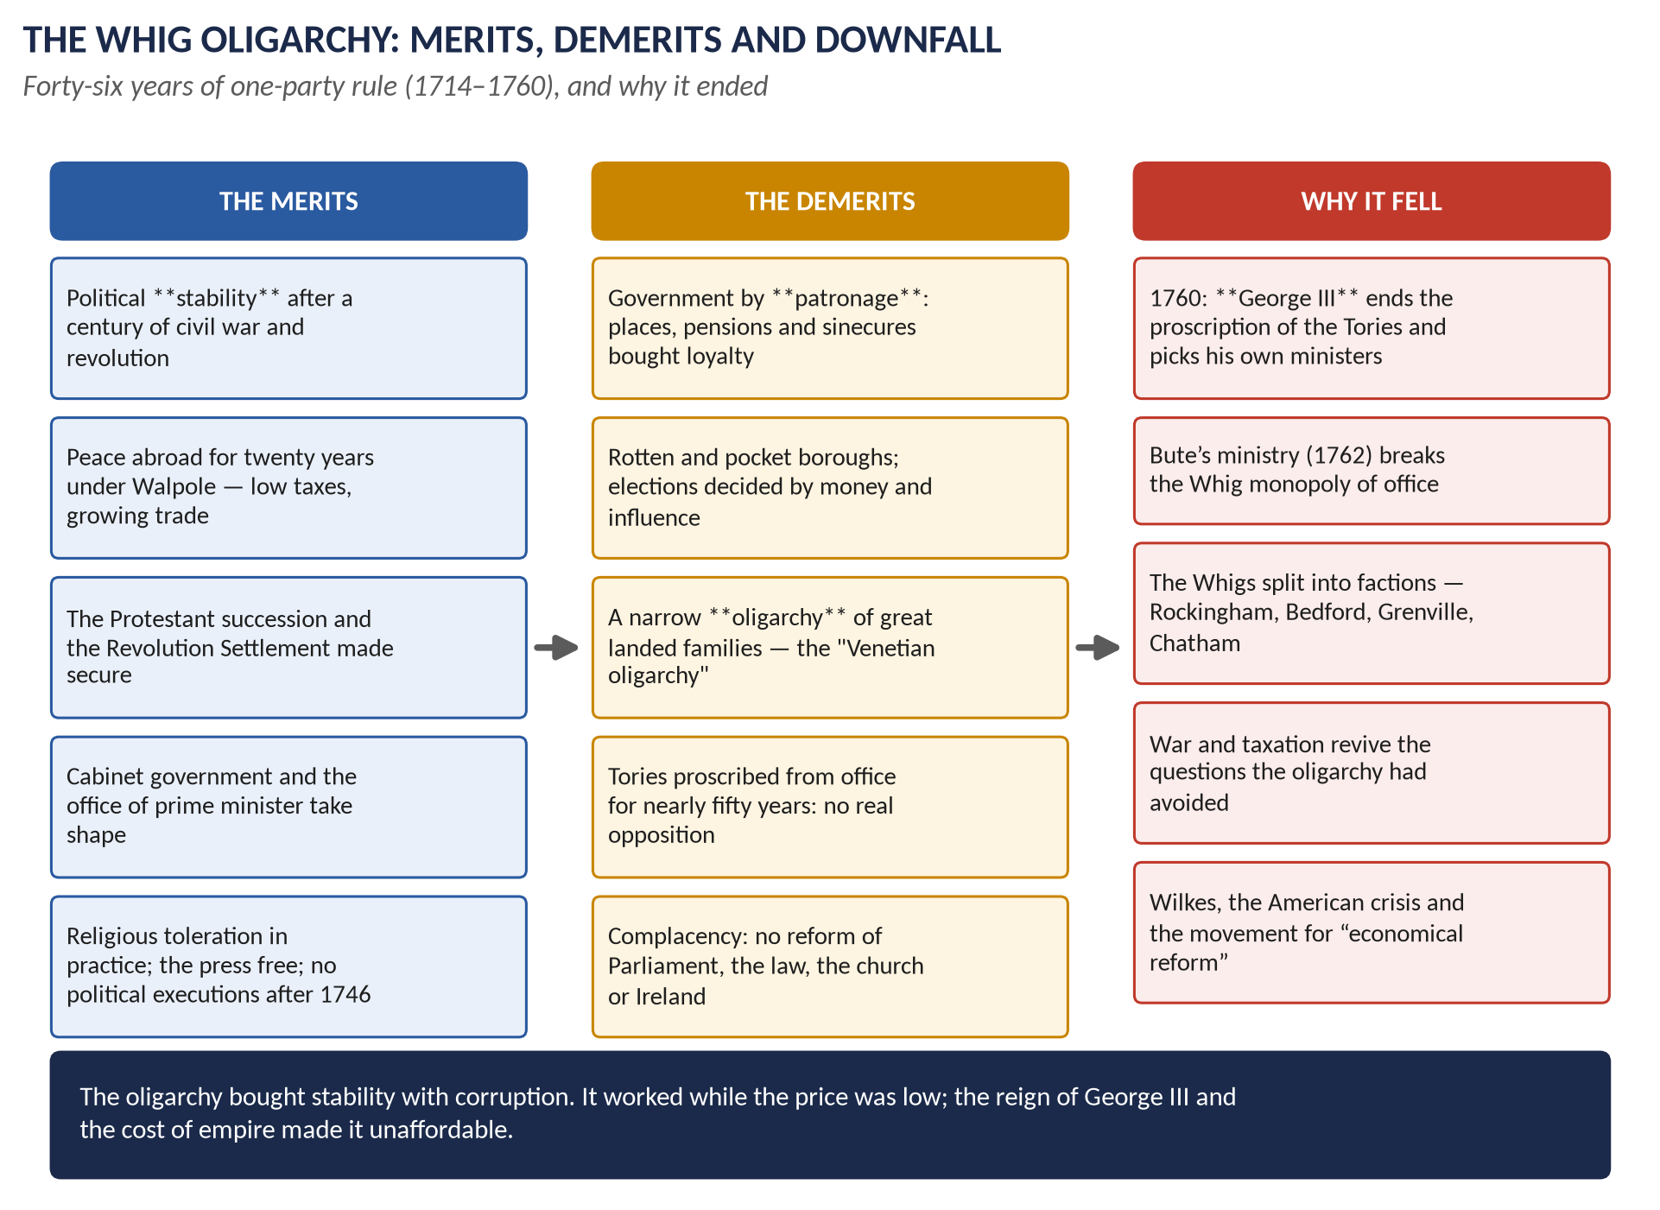
Figure 2 · The political consequence of 1714: half a century of Whig rule — its merits, its demerits and its end.

(11) The limits of the change
The Crown remained powerful. It chose ministers, controlled the vast patronage of the state, made war and peace, and could destroy a ministry by withdrawing its confidence. George III demonstrated all of this after 1760, when he ended the proscription of the Tories and appointed Bute. The constitutional shift of 1714–60 was a matter of practice, not of new law, and it could be — and was — partly reversed.

(12) Conclusion
Politically the Hanoverian succession delivered Britain to the Whigs for half a century, made Jacobitism the permanent alternative, and turned politics into the management of interests. Constitutionally it confirmed that the crown rests on statute, and allowed the cabinet and the prime minister to develop — culminating in Walpole's resignation of 1742, the moment when a minister first fell because the Commons, and not the king, had withdrawn its support.
WHY THIS ANSWER SCORES
Both named dimensions get their own block of headings, and the answer explains how the political facts (a foreign, absent king; a proscribed opposition) produced the constitutional results. The limits section prevents the common error of describing 1714 as the birth of modern democracy.

Answer 2 · Walpole in Four Roles
THE QUESTION · CSS 2015 · Q4 · Paper I · 20 marks
Evaluate analytically and critically the role of Walpole as Secretary of State, Prime Minister, party organiser and financier.

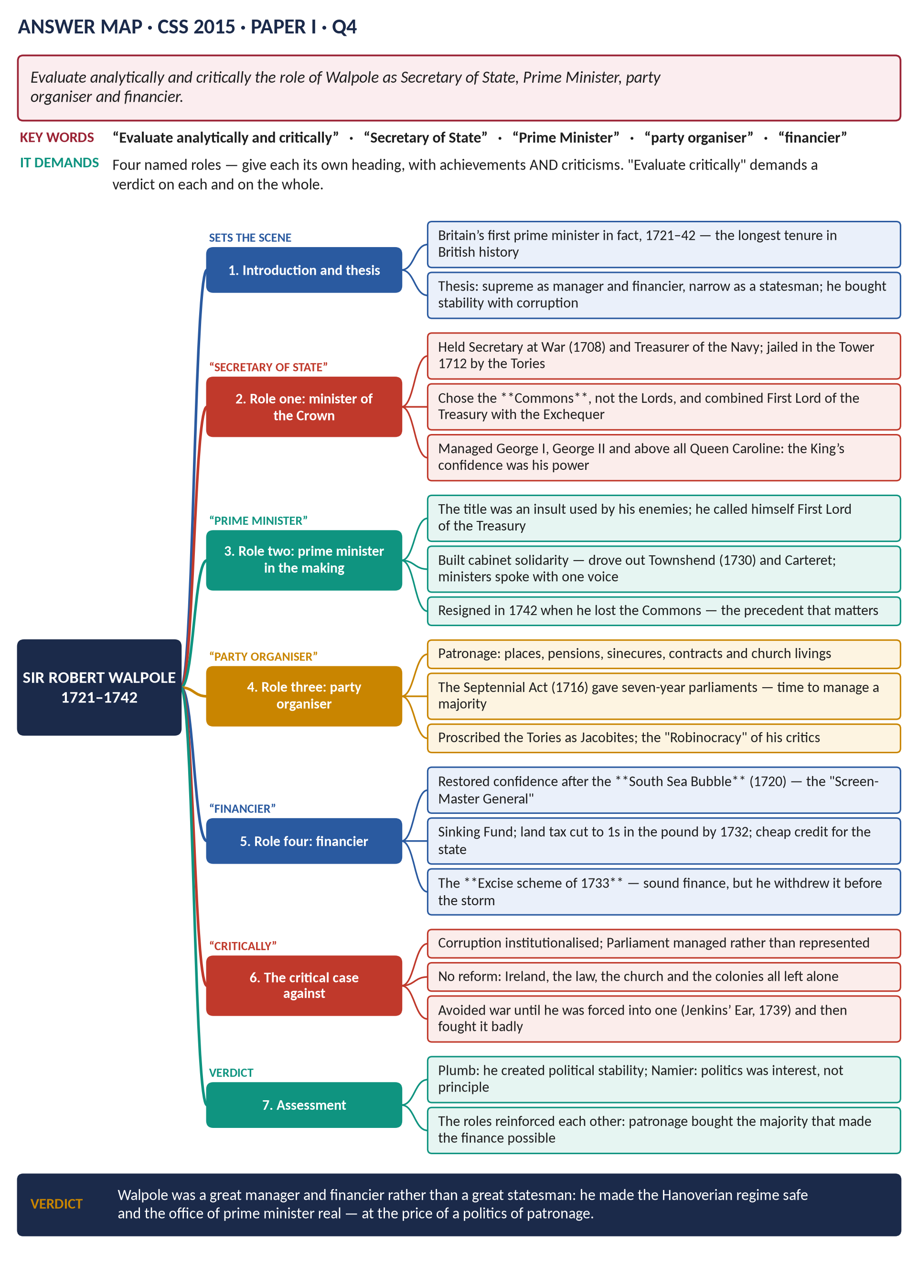
Figure 3 · The answer map for CSS 2015 · Q4 · Paper I: every branch is one heading of the answer below.
DECODING THE QUESTION
The question names four roles — Secretary of State, Prime Minister, party organiser and financier. Give each its own heading; in each, state the achievement and then the criticism, because "evaluate analytically and critically" demands judgement, not description. End with an overall verdict.

The model answer

(1) Introduction and thesis
Sir Robert Walpole (1676–1745) dominated British politics for twenty-one years, from 1721 to 1742 — still the longest tenure of any British prime minister. He was supreme as a manager of men and money and limited as a statesman: he made the Hanoverian regime safe and the office of prime minister real, but he did so by building a system of patronage that his critics called the "Robinocracy" and that left Britain unreformed.

(2) Role one: minister of the Crown

(i) The offices
Walpole rose through Secretary at War (1708) and Treasurer of the Navy, was imprisoned in the Tower by the Tories in 1712 — which made him a Whig martyr — and returned after 1714. From 1721 he held First Lord of the Treasury and Chancellor of the Exchequer together, uniting policy and money in one pair of hands.

(ii) Managing the monarch
No eighteenth-century minister could survive without the king. Walpole kept the confidence of George I, and of George II after 1727 — largely through Queen Caroline, the king's closest adviser. His enemies said he governed by the back stairs; but the constitution still gave the Crown the choice of ministers, and managing it was part of the job.

(iii) The criticism
His dependence on court favour was a weakness as well as a strength: it made him vulnerable whenever the heir to the throne (Frederick, Prince of Wales) became the focus of opposition.

(3) Role two: prime minister in the making

(i) What he created
- He refused a peerage and stayed in the Commons, recognising that the House that voted money held the power.
- He insisted on cabinet solidarity, forcing out Townshend (1730) and Carteret: ministers were to speak with one voice.
- He accepted 10 Downing Street from George II in 1735 as an official residence for the First Lord of the Treasury.
- He resigned in 1742 when his majority failed — the precedent that matters more than any title.

(ii) The criticism
He never claimed the title and denied being a prime minister at all, because the term implied an unconstitutional concentration of power. He also destroyed able colleagues rather than work with them, which left a shallow bench when he fell.

(4) Role three: party organiser

(i) The machine
- Patronage: places in the customs, excise, army, navy and church; pensions; government contracts.
- The Septennial Act (1716) gave seven years between elections — long enough to manage a majority.
- The Treasury and the great borough patrons together managed elections in a system of rotten and pocket boroughs with perhaps one adult man in five able to vote.
- He kept the Tories out by identifying them with Jacobitism — an identification the Fifteen and the Forty-Five made easy.

(ii) The criticism
This was corruption organised as government. Parliament was managed rather than representative; opposition was reduced to a faction around the Prince of Wales; and the system postponed every question of reform for a century.

(5) Role four: financier

(i) The achievements
- After the South Sea Bubble (1720) he restored confidence and protected the Crown and ministers from the worst of the scandal — the "Screen-Master General".
- He revived the sinking fund to reduce the National Debt and kept government credit cheap.
- He cut the land tax to 1s in the pound by 1732 — the tax paid by the gentry who sat in Parliament, which was also shrewd politics.
- He encouraged trade by reducing duties on exports and raw materials.

(ii) The excise scheme of 1733
His plan to replace customs duties on wine and tobacco with excise — collected in bonded warehouses, which would have cut smuggling and fraud — was sound finance and good administration. A propaganda campaign about "excisemen" invading English homes ("no slavery, no excise, no wooden shoes") forced him to withdraw it. He accepted defeat rather than force it through: "I will not be the minister to enforce taxes at the expense of blood."
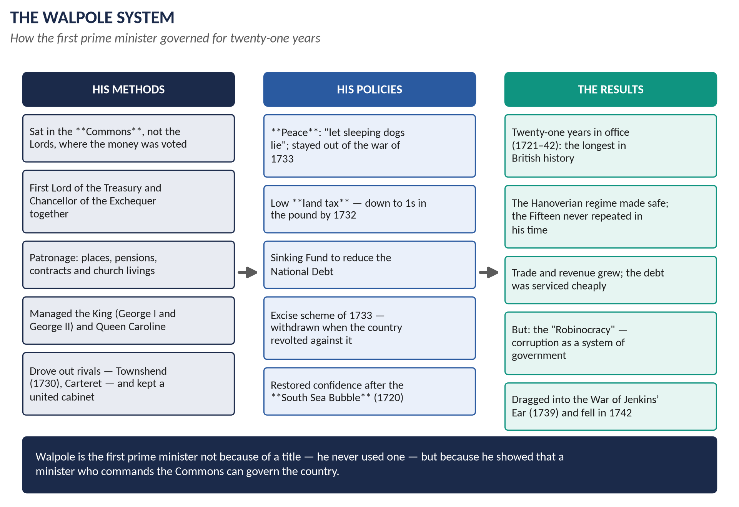
Figure 4 · The Walpole system: how methods, policies and results reinforced one another.

(6) The critical case against Walpole
1. Corruption institutionalised: the machine outlived him and became the target of every reformer from Wilkes to the Younger Pitt.
2. No reform: Ireland, the colonies, the law, the Church and the poor were all left untouched.
3. A narrow foreign policy: his peace was valuable, but his refusal to think about the colonial struggle left Britain unprepared in 1739, and he then fought the War of Jenkins' Ear without conviction.
4. Intolerance of rivals: the talent he excluded — Carteret, Chesterfield, Pitt — became a permanent opposition.

(7) Assessment
The four roles supported each other: patronage bought the majority; the majority secured the king's confidence; the king's confidence delivered the Treasury; the Treasury supplied the patronage. Plumb credits him with creating the political stability Britain had lacked since 1642; Namier would say the system, not the man, explains the politics. Both agree the achievement was real.

(8) Conclusion
Walpole was a great manager and a great financier rather than a great statesman. As a minister of the Crown he mastered the court; as prime minister in all but name he created the office; as party organiser he built a machine that gave Britain fifty years of stability; as financier he restored the nation's credit and kept taxes low. The price was a politics of patronage and a generation of unreform — a price his own country paid after 1760.
WHY THIS ANSWER SCORES
Each of the four named roles is a heading, and each carries both achievement and criticism, which is what "evaluate analytically and critically" demands. The closing assessment shows the roles as one system rather than four separate topics — the analytical point that lifts the answer.

Answer 3 · The Merits, Demerits and Downfall of Whig Rule
THE QUESTION · CSS 2017 · Q2 · Section A · 20 marks
What were the merits and demerits of Whig rule? What led to the downfall of Whig ascendancy? Analyze comprehensively.

Figure 5 · The answer map for CSS 2017 · Q2 · Section A: every branch is one heading of the answer below.
DECODING THE QUESTION
Three named limbs: merits, demerits, and what led to the downfall. "Analyze comprehensively" means each limb must be argued with evidence and then weighed. Define the period first (1714–60), or the answer will drift into the nineteenth century.

The model answer

(1) Introduction and thesis
Between 1714 and 1760 one party held office almost without interruption. The Whig oligarchy — sometimes called the Whig supremacy or ascendancy — rested on the Hanoverian succession, the proscription of the Tories, and a system of patronage perfected by Walpole and Newcastle. It gave Britain the political stability it had lacked for a century, and it did so at the cost of corruption and of a Parliament that represented property rather than people. It fell after 1760 because a new king wanted his own ministers, and because the Whigs, without an enemy, dissolved into factions.

(2) How the Whigs came to monopolise power
- 1714: George I distrusted the Tories, who had made the Peace of Utrecht and whose leader Bolingbroke fled to the Pretender.
- 1715: the Jacobite rising confirmed the taint; "Tory" and "Jacobite" became interchangeable in Whig propaganda.
- 1716: the Septennial Act stretched parliaments to seven years.
- 1720–21: the South Sea Bubble destroyed rivals and brought Walpole to the top.

(3) The merits

(i) Political stability
Britain had endured civil war, regicide, a republic, a restoration, a revolution and two disputed successions between 1642 and 1714. After 1714 it had fifty years without any of them. J. H. Plumb argued that this stability was created, not inherited — by single-party rule, the Septennial Act and patronage.

(ii) Peace, trade and low taxation
Walpole kept Britain out of European war from 1721 to 1739. Trade, shipping and customs revenue grew; the land tax fell to 1s in the pound; government credit was cheap, which mattered greatly when war came.

(iii) The Revolution Settlement secured
The Protestant succession survived two risings. No minister attempted to revive the prerogative powers destroyed in 1689; the Bill of Rights and the Act of Settlement became part of the furniture of politics.

(iv) Constitutional development
Cabinet government and the office of prime minister took shape in these years, and in 1742 a minister resigned because he had lost the Commons — the central convention of British government.

(v) Practical toleration and a free press
Dissenters were protected by annual Indemnity Acts; the press, unlicensed since 1695, was noisy and critical; after 1746 there were no political executions.

(4) The demerits

(i) Government by patronage
Places, pensions, sinecures and contracts held the majority together. Perhaps a fifth of MPs were placemen. Contemporaries called it the "Robinocracy"; modern historians call it management.

(ii) An unrepresentative Parliament
Rotten and pocket boroughs returned members for a handful of voters — Old Sarum is the standing example — while growing towns like Manchester and Birmingham returned none. About one adult man in five could vote in England.

(iii) Oligarchy
A few great families — Pelham, Cavendish, Russell, Campbell — monopolised office, honours and church preferment. Disraeli later called them a "Venetian oligarchy".

(iv) No opposition, and no reform
With the Tories proscribed, opposition was reduced to a "Patriot" faction around Frederick, Prince of Wales. Nothing was reformed: not Parliament, not the law, not the Church, not the poor law, not Ireland, not colonial government.

(5) What led to the downfall
Cause | How it worked
George III (1760) | A British-born king of 22 who meant to choose his own ministers; he ended the proscription of the Tories and built the "King's Friends"
Bute (1762) | The King's tutor made prime minister; the Whig families found themselves in opposition for the first time in half a century
Factionalism | Without a common enemy the Whigs split into Rockingham, Grenville, Bedford and Chatham connections — seven ministries between 1760 and 1770
New political forces | Wilkes and the Middlesex elections; general warrants; the reporting of debates (1771); petitions and "economical reform"
The American crisis | A system built for management had no answer to an imperial question requiring imagination; failure abroad discredited it at home

Figure 6 · The Whig oligarchy in three columns: merits, demerits, and the causes of its fall.

(6) The historians' debate
- Plumb: the oligarchy produced the stability that made everything else — commerce, empire, the Enlightenment in Britain — possible.
- Namier: it was never a "party" in the modern sense; politics was structured by interest and family, and George III's actions in 1760 were entirely constitutional.
- Butterfield: Namier went too far; principle and party did matter, and the Whigs did stand for the Revolution.

(7) Conclusion
The merits of Whig rule were stability, peace, prosperity and the quiet growth of the constitution; its demerits were corruption, oligarchy and the complete absence of reform. It fell not because the country rose against it but because George III exercised a power the constitution gave him, and because the Whigs had become a collection of connections with nothing to say to a changing country. The oligarchy bought stability with patronage: a bargain that was worth making in 1714 and indefensible by 1760.
WHY THIS ANSWER SCORES
The three named limbs are separated and each is argued with evidence, not asserted. The downfall table shows five distinct causes rather than one, and the historians' paragraph supplies the "comprehensive analysis" the question asks for.

Answer 4 · The Same Question, Re-angled
THE QUESTION · CSS 2020 · Q2 · Section A · 20 marks
What are the merits and demerits of the Whig oligarchy? Critically examine the causes of the downfall of Whig ascendancy.

DECODING THE QUESTION
Compare the two wordings. 2017: "What were the merits and demerits of Whig rule? What led to the downfall of Whig ascendancy? Analyze comprehensively." 2020: "What are the merits and demerits of the Whig oligarchy? Critically examine the causes of the downfall of Whig ascendancy." The material is the same; the weighting is different.

How to adapt Answer 3
 | 2017 wording | 2020 wording
Weighting | Roughly equal between the three limbs | The downfall carries more weight: "critically examine the causes"
Command word | "Analyze comprehensively" — cover the ground | "Critically examine" — test each cause and rank them
Key noun | "Whig rule" | "Whig oligarchy" — define the word and use it
Suggested split of 35 minutes | 12 / 12 / 11 | 9 / 9 / 17

The three changes to make
1. Define "oligarchy" in the introduction. Government by a small group — here, perhaps forty great families holding office, honours and patronage; the electorate about one adult man in five; the Tories excluded. Using the question's own word in your definition earns marks immediately.
2. Expand the downfall into the main section, with a heading for each cause and a judgement on each:
  - George III's accession (1760) — necessary and sufficient? It removed the proscription and the Whigs' monopoly of the King's confidence. The decisive cause.
  - Bute's ministry (1762) — the proof rather than the cause.
  - Whig factionalism — a pre-existing weakness that George III's action exposed.
  - Wilkes and popular radicalism — evidence that opinion outside Parliament now mattered; a symptom more than a cause.
  - The American crisis — destroyed the system's reputation, but after its political monopoly had already gone.
3. Rank them explicitly: the accession of George III was the trigger; the Whigs' internal decay was the underlying cause; Wilkes and America were accelerators. A "critically examine" question is marked on exactly this ranking.

The conclusion to use for 2020
The Whig oligarchy fell because a king determined to use his lawful powers met a party that had lost its purpose. George III's accession in 1760 was the occasion, and Bute's appointment the demonstration; but the deeper cause was that fifty years of unopposed management had turned a party into a collection of connections, incapable of meeting the demands of a new reign, a new public and a new empire.
WHY THIS ANSWER SCORES
Examiners set the same family of question repeatedly, changing the angle (Master Anatomy, Part 3.4). Showing the two wordings side by side, and the different time split they demand, is worth more than a second full answer.

Short Notes

The Jacobite Revolt of Scotland
THE QUESTION · CSS 2015 · Q8(c) · Paper I · short note (10 marks)
Write a short note on: Jacobite Revolt of Scotland

DECODING THE QUESTION
A short note of 10 marks, about 450–600 words in 17 minutes. Use the five-part shape: definition → background → main events → significance → one-line assessment. "The Jacobite Revolt of Scotland" means the risings as a whole; concentrate on the Forty-Five, with the Fifteen as background.

(1) Definition
Jacobitism was the movement to restore the exiled Stuart line — James II, his son James Francis Edward (the "Old Pretender") and his grandson Charles Edward (the "Young Pretender") — to the thrones of Britain. Its name comes from the Latin Jacobus, James. Its main risings were the Fifteen (1715) and the Forty-Five (1745–46).

(2) Background
James II was deposed in 1688; the Act of Settlement (1701) gave the crown to Hanover. Jacobitism drew on the dynastic claim, on Catholicism in parts of the Highlands and Ireland, on Episcopalianism in north-east Scotland, on anti-Union feeling after 1707, and on French interest in weakening Britain.

(3) The main events

(i) The Fifteen
The Earl of Mar raised the standard at Braemar in September 1715 and gathered perhaps 10,000 men. The indecisive battle of Sheriffmuir (13 November) and the surrender at Preston the next day ended it; the Old Pretender arrived in December and left in February.

(ii) The Forty-Five
- August 1745: Charles Edward lands with seven companions and raises his standard at Glenfinnan.
- September: he takes Edinburgh and wins Prestonpans.
- November–December: he invades England, takes Carlisle and reaches Derby on 5 December — causing panic in London ("Black Friday") — before his chiefs insist on retreat.
- January 1746: a last victory at Falkirk.
- 16 April 1746: the Duke of Cumberland destroys the Highland army at Culloden in under an hour.

(4) Why it failed
No English Jacobite rising; no French landing; only about 5,000 men against three converging armies; the Lowlands, the towns and the Presbyterian Kirk hostile; and the government's command of the sea and of credit.

(5) The aftermath and significance
About 120 executions, including Lord Lovat (1747), and roughly a thousand transportations. The Act of Proscription (1746) banned Highland dress and disarmed the clans; the Heritable Jurisdictions Act (1747) abolished the chiefs' private courts — the legal end of the clan system. Forfeited estates were annexed and "improved"; military roads and Fort George secured the Highlands.

(6) Assessment
The Forty-Five was the most serious internal challenge the Hanoverian regime ever faced, and its defeat settled three things: the dynasty was safe, the Highlands were opened to the state and to emigration, and Britain was free to turn its whole strength against France overseas — which it did within ten years, in the Seven Years' War. As Bruce Lenman argues, Jacobitism was a serious political movement, not merely a romantic lost cause.
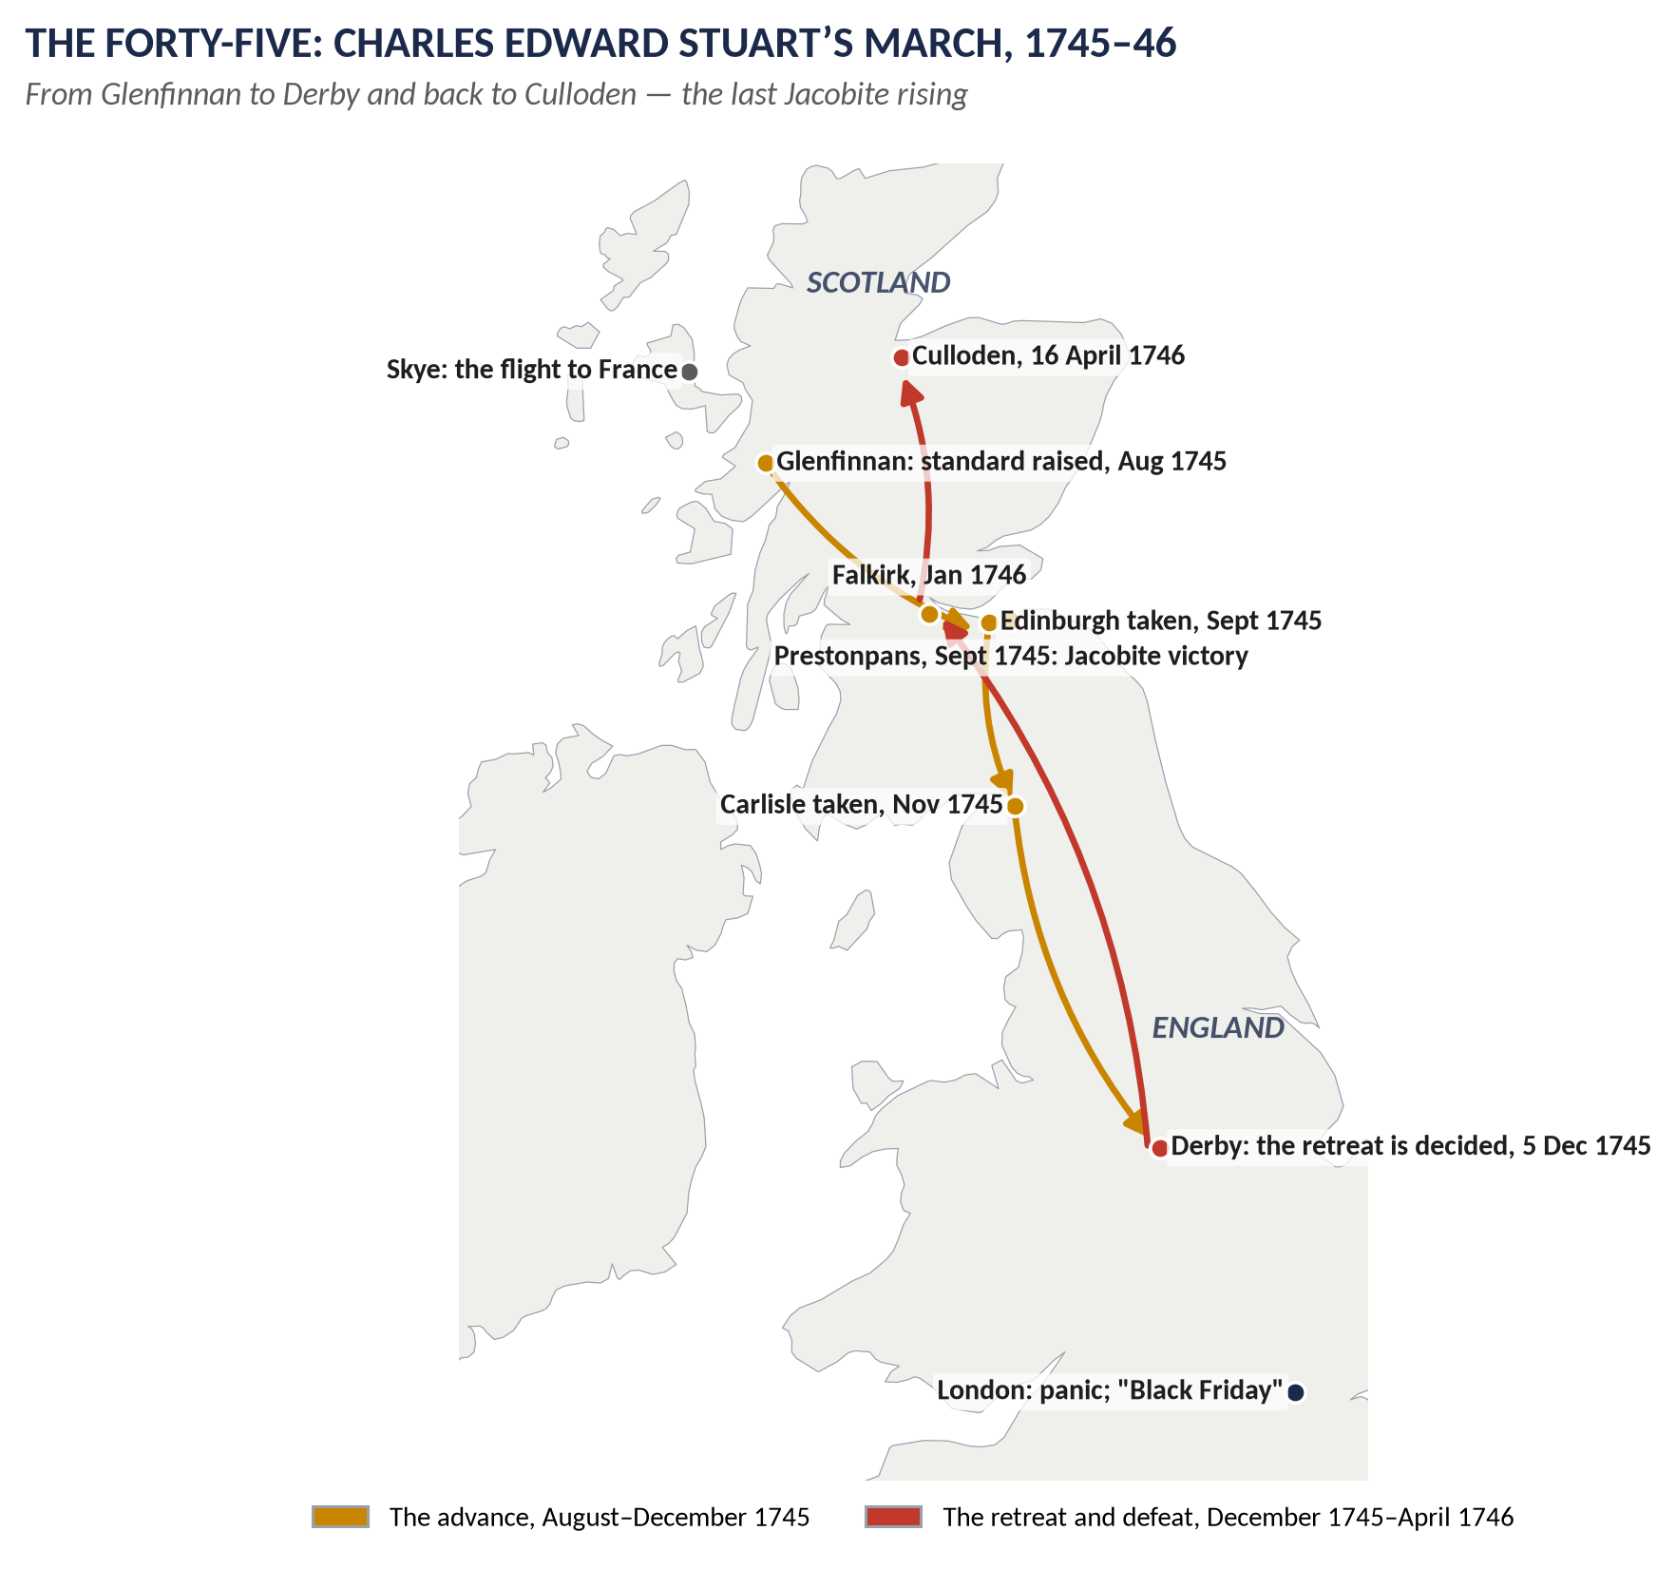
Figure 7 · The Forty-Five: Glenfinnan to Derby, and the retreat to Culloden.

Answer 5 · Chatham: "A Glorious Success Until 1761 and Then Failure"
THE QUESTION · CSS 2022 · Q3 · Section A · 20 marks
'A glorious success until 1761 and then failure.' Do you agree with this estimate of the career of Chatham?

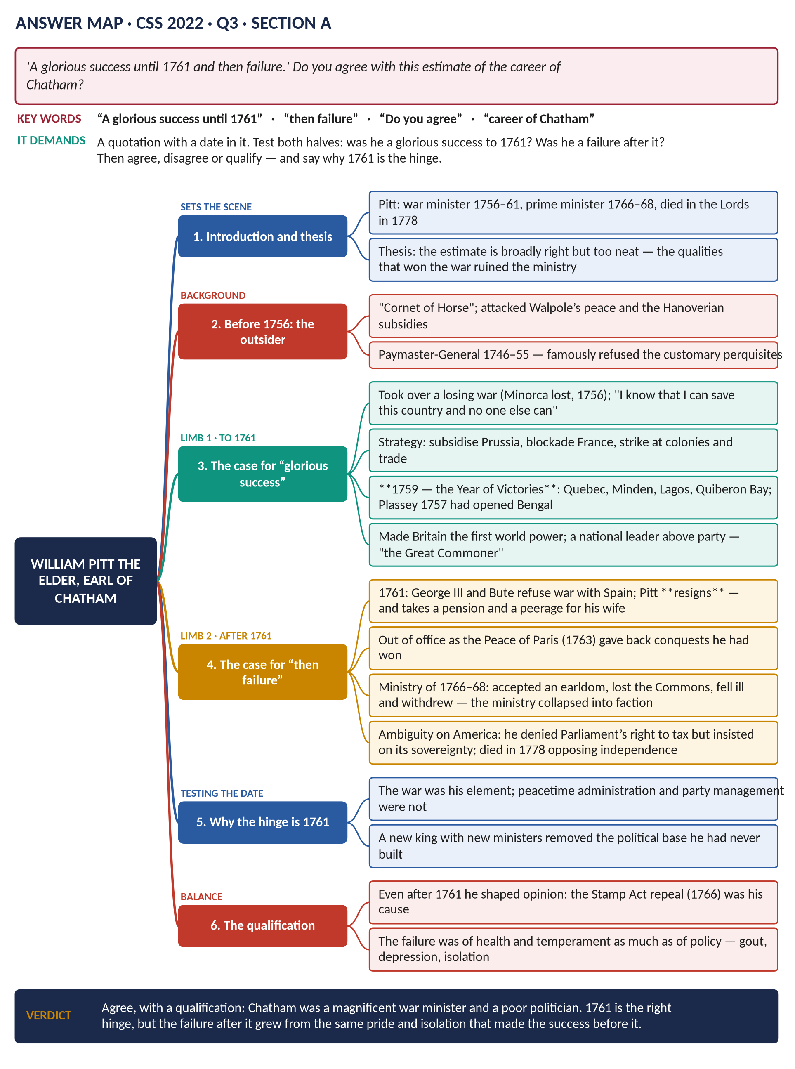
Figure 8 · The answer map for CSS 2022 · Q3 · Section A: every branch is one heading of the answer below.
DECODING THE QUESTION
A quotation with a date in it. Test both halves — was he a glorious success to 1761? was he a failure after it? — and then say whether you agree, disagree or agree with qualification. You must explain why 1761 is the hinge; that is where the analysis lives.

The model answer

(1) Introduction and thesis
William Pitt the Elder (1708–78), from 1766 Earl of Chatham, directed Britain's war effort from 1757 to 1761 and led a ministry from 1766 to 1768. The estimate quoted is broadly right but too neat. Pitt was a magnificent war minister and a poor politician, and 1761 is the correct hinge — but the same qualities of pride, independence and refusal to build a party produced both the triumph before it and the collapse after it.

(2) Before 1756: the outsider
Pitt entered Parliament in 1735 as the "Cornet of Horse" and made his name attacking Walpole's peace policy and the Hanoverian subsidies — "a great kingdom made a province of a despicable electorate". As Paymaster-General (1746–55) he refused the customary perquisites, which gave him a reputation for incorruptibility in a corrupt age. George II disliked him and kept him from high office until national emergency made him unavoidable.

Limb one — the case for "glorious success" to 1761

(3) He took over a losing war
Britain entered the Seven Years' War in 1756 with Minorca lost and Admiral Byng awaiting court-martial. Pitt's claim — "I know that I can save this country and nobody else can" — was arrogant and, as it turned out, justified.

(4) He devised a winning strategy
- Subsidise Prussia: Frederick the Great tied down the French and Austrian armies in Germany. "America was conquered in Germany."
- Fight a maritime war: blockade French ports, protect trade, and use the navy to carry armies against French colonies.
- Promote by merit: Wolfe, Amherst, Hawke and Clive were advanced over their seniors.
- Pay for it: unprecedented borrowing, sustained by the credit the Revolution Settlement had created.

(5) The results
1759 is remembered as the "Year of Victories": Quebec (Wolfe), Minden, Lagos and Quiberon Bay (Hawke). Plassey (1757) had already made the East India Company the power in Bengal; Louisbourg fell in 1758, Guadeloupe and Senegal the same year, Montreal in 1760. Britain emerged the leading world power.

(6) He governed as a national leader
Pitt drew his strength from the City of London, the merchants and public opinion rather than from a party machine — the "Great Commoner" whose popularity was a political force in itself.
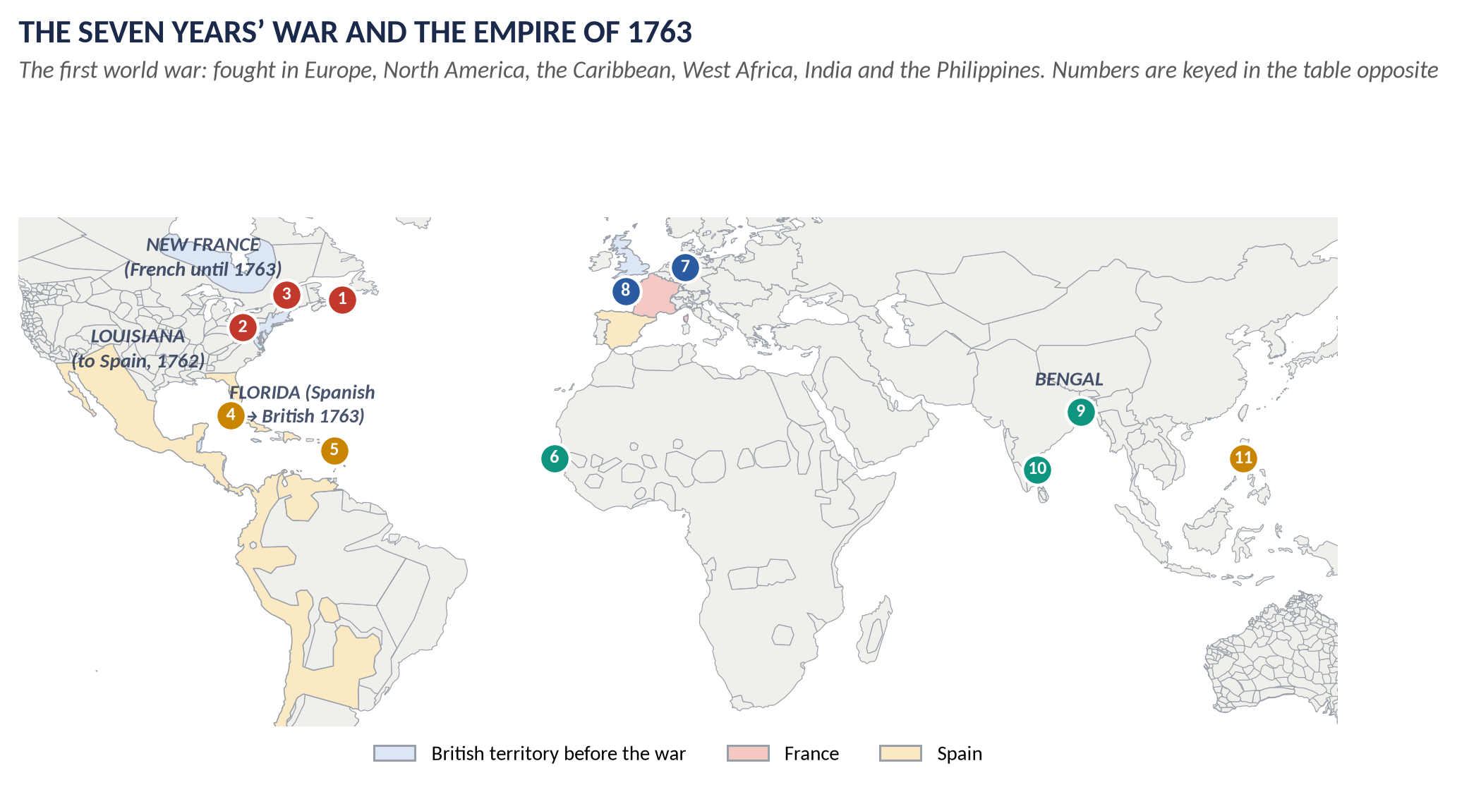
Figure 9 · Chatham's war, 1756–63: the campaigns that made Britain a world power.

Limb two — the case for "then failure"

(7) The resignation of 1761
When Pitt learned of the Family Compact between the French and Spanish Bourbons, he demanded a pre-emptive declaration of war on Spain. The cabinet refused; he resigned in October 1761. Spain declared war three months later, which proved him right — but he had left office.

(8) The pension and the peerage
He accepted a pension of £3,000 a year and a peerage for his wife. To his admirers in the City this looked like the Great Commoner being bought; his moral authority never fully recovered.

(9) The Peace of Paris and the lost decade
Out of office, he watched Bute return Guadeloupe, Martinique and Manila in the Treaty of Paris (1763) — conquests he had won. For five years he was a figure of opposition, increasingly ill.

(10) The failed ministry of 1766–68
- He accepted the Earldom of Chatham, leaving the Commons — where his power had always lain.
- He took the sinecure office of Lord Privy Seal instead of the Treasury, so he neither led the Commons nor controlled the money.
- Severe illness and depression removed him from business for months; the ministry drifted under Grafton, which is how the Townshend duties of 1767 — a measure Chatham would never have chosen — came to be passed.

(11) Ambiguity on America
Chatham denied Parliament's right to tax the colonies (he rejoiced at the repeal of the Stamp Act in 1766) but insisted on its sovereignty over them. He opposed American independence to the end, collapsing in the Lords in April 1778 while arguing against it. It was a principled position, but it satisfied nobody.

(12) Testing the date: why 1761?
The hinge is real because it separates the two halves of his character:
War (to 1761) | Peace (after 1761)
A single clear objective — defeat France | Many competing objectives; no majority to deliver them
Authority drawn from popular acclaim | Authority requires party management, which he despised
Colleagues he could command | Colleagues he had to conciliate, and did not
Health sufficient for two years of crisis | Gout and depression that removed him for months

(13) The qualification
Even after 1761 he mattered. The repeal of the Stamp Act (1766) was his cause; his warnings about America were prophetic; and his reputation sustained the idea of a patriot minister above faction that later inspired his son, the Younger Pitt.

(14) Conclusion
Agree, with a qualification. Chatham's career to 1761 was a glorious success — the Year of Victories, Canada, Bengal and a world empire. After 1761 it was, in office, a failure: a resignation that surrendered influence, a peerage that removed him from his own source of power, and a ministry that disintegrated in his absence. But the failure grew from the same soil as the success: a man who would not build a party, would not conciliate rivals and would not compromise is magnificent in war and helpless in peace.
WHY THIS ANSWER SCORES
Both halves of the quotation are tested, the date is explained rather than accepted, and the comparison table makes the analytical point — the same qualities produced both outcomes — which is what a "do you agree" question rewards.

Answer 6 · Abolition, Imperialism and Economic Interests
THE QUESTION · CSS 2026 · Q2 · Section A · 20 marks
Examine the complex relationships between abolition, imperialism, and economic interests, and argue for or against the notion that Britain's anti-slavery movement was a thinly veiled justification for colonial expansion.

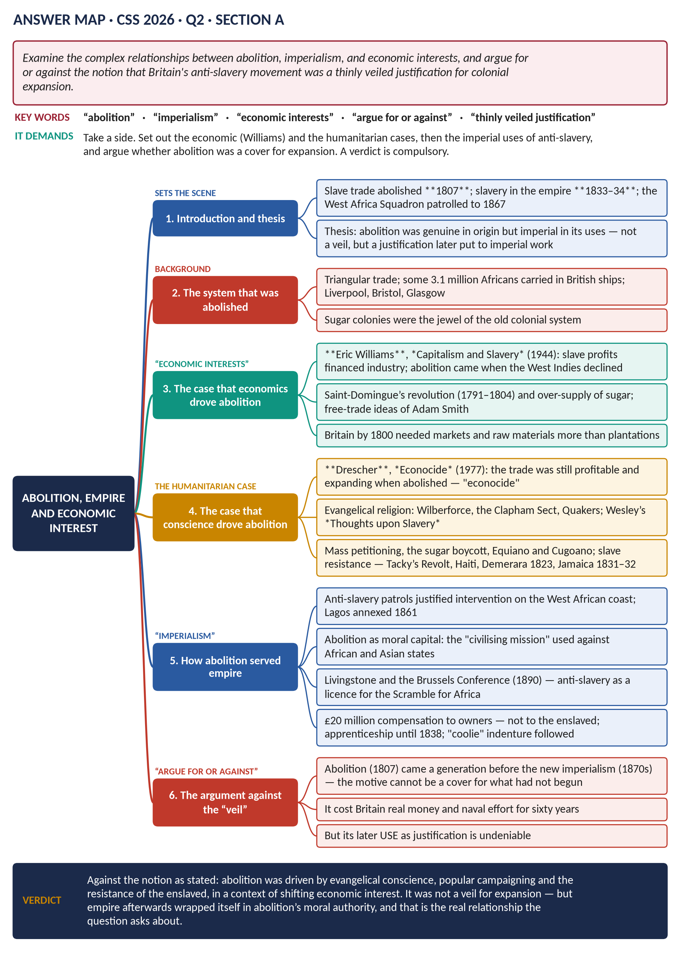
Figure 10 · The answer map for CSS 2026 · Q2 · Section A: every branch is one heading of the answer below.
DECODING THE QUESTION
The question asks you to argue for or against a proposition: that Britain's anti-slavery movement was "a thinly veiled justification for colonial expansion". You must set out the economic argument (Williams), the humanitarian argument (Drescher and others), and the imperial uses of anti-slavery — then take a side. The strongest answer distinguishes abolition's origins from its later uses.

The model answer

(1) Introduction and thesis
Britain abolished the slave trade in 1807 and slavery in its empire in 1833–34, and then policed the Atlantic against slavers for sixty years. The proposition that this was "a thinly veiled justification for colonial expansion" cannot be sustained as an account of why abolition happened: it came a generation before the new imperialism, and it cost Britain money, ships and lives. But it is right about what happened afterwards — anti-slavery became the moral language in which later imperial expansion was justified. Abolition was not a veil; it became a licence.

(2) The system that was abolished
British ships carried roughly 3.1 million enslaved Africans; about 400,000 died on the Middle Passage. Liverpool, Bristol and London grew on the trade, and the sugar islands were the most valuable colonies Britain possessed — worth more, in the debates of 1763, than the whole of Canada.
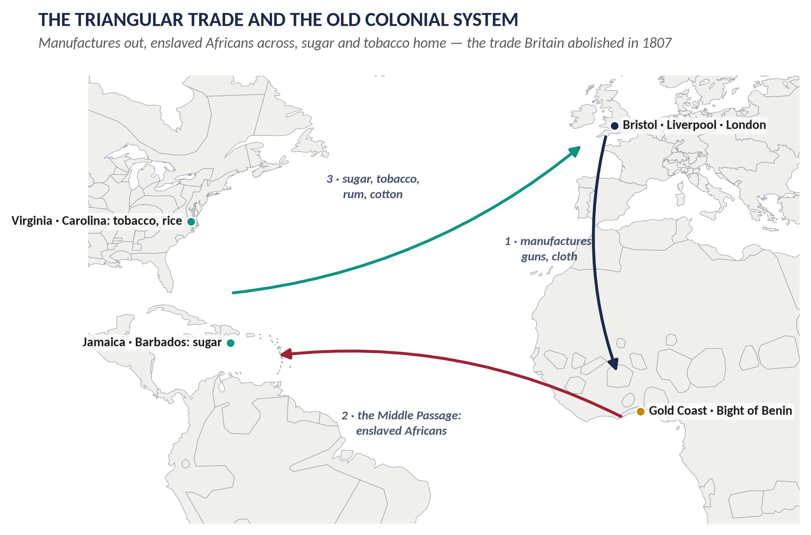
Figure 11 · The triangular trade that abolition destroyed.

(3) The economic argument: Eric Williams
Eric Williams, Capitalism and Slavery (1944), made two claims:
1. Profits from slavery and the slave trade helped finance the Industrial Revolution.
2. Abolition came when the West Indian interest was declining — over-produced sugar, the loss of the American market, competition from Cuba and Brazil, and the rise of free-trade ideas. Humanitarianism, on this view, was the respectable dress of economic self-interest.
Supporting evidence: the Saint-Domingue revolution (1791–1804) destroyed the richest slave colony; Adam Smith (1776) had argued that slave labour was the dearest of all; industrial Britain increasingly wanted markets and raw materials rather than plantations.

(4) The humanitarian reply: Drescher and the movement
Seymour Drescher, Econocide (1977), tested Williams against the trade figures and found the opposite: British slave-trading and West Indian production were expanding in the 1790s and 1800s. Abolition destroyed a profitable system — "econocide" — and must therefore be explained politically and morally.
The evidence for a genuine movement is overwhelming:
- Evangelical religion: the Clapham Sect, Wilberforce, Quakers from the 1780s; Wesley's Thoughts upon Slavery (1774).
- Mass mobilisation: the Abolition Society (1787), Clarkson's tours and evidence-gathering, petitions with hundreds of thousands of signatures, the boycott of slave-grown sugar by perhaps 300,000 families.
- Black voices: Olaudah Equiano's Interesting Narrative (1789), Ottobah Cugoano, and the Sons of Africa.
- Resistance by the enslaved: Tacky's Revolt (1760), Haiti, Demerara (1823) and the Jamaica rising of 1831–32, after which planters themselves admitted the system could not be held down.
- Cost: the West Africa Squadron absorbed a significant share of the navy for half a century and lost thousands of sailors to disease.

(5) How abolition served empire
The proposition is not simply wrong, because anti-slavery did real imperial work:
1. A licence to intervene. Anti-slavery treaties and patrols gave the Royal Navy the right to stop other nations' ships and to act on the West African coast; Lagos was bombarded and annexed (1851, 1861) partly on anti-slavery grounds.
2. Moral capital. Britain presented itself as the liberator of Africa, which answered criticism of its own conquests.
3. The civilising mission. Livingstone's campaign against the East African trade, and the Brussels Conference of 1890, wrote anti-slavery into the Scramble for Africa: suppressing the slave trade became a recognised ground for annexation.
4. The limits of emancipation. The £20 million compensation went to owners, not to the enslaved; "apprenticeship" kept people working until 1838; and indentured labour from India and China replaced slavery in the plantations. This is the strongest evidence for the sceptical case.

(6) The argument against the proposition
- Chronology. The trade was abolished in 1807 and slavery in 1833; the new imperialism in Africa began in the 1870s–80s. A motive cannot be a cover for something that had not yet begun.
- Cost. Abolition destroyed a profitable trade, damaged a powerful colonial lobby and required sixty years of expensive naval patrolling.
- Agency. The movement's driving forces — Nonconformist religion, popular petitioning, and above all the revolts of the enslaved — were not instruments of the Colonial Office.
- Opposition from the imperial interest. The West India lobby, the great imperial interest of the day, fought abolition to the last.

(7) Conclusion
The relationship between abolition, empire and economics is real but sequential rather than conspiratorial. Economic change made abolition possible; conscience, popular politics and slave resistance made it happen; and empire afterwards made use of it. I therefore argue against the proposition as stated: Britain's anti-slavery movement was not a thinly veiled justification for colonial expansion, but it supplied the vocabulary and the moral authority with which a later generation justified that expansion — which is why the two are so easily, and so wrongly, identified.
WHY THIS ANSWER SCORES
The question demands a side, and the answer takes one explicitly in the introduction and the conclusion. Both historians are named and used, not just cited; the imperial uses of abolition are conceded in full, which makes the final distinction between origins and uses convincing rather than defensive.

Answer 7 · The American War: The Balance Sheet for Britain
THE QUESTION · CSS 2015 · Q5 · Paper I · 20 marks
Shed light on the American War of Independence with special reference to its debit side and credit side for Great Britain.

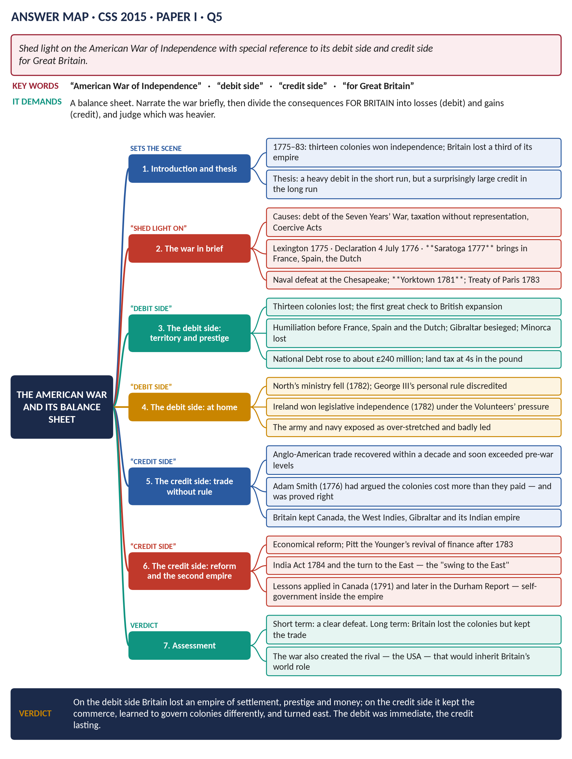
Figure 12 · The answer map for CSS 2015 · Q5 · Paper I: every branch is one heading of the answer below.
DECODING THE QUESTION
"Shed light on" asks for an account of the war; the marks are in the "debit side and credit side for Great Britain" — a balance sheet of consequences. Narrate briefly, then divide the consequences into losses and gains, and judge which was heavier and over what period.

The model answer

(1) Introduction and thesis
The American War of Independence (1775–1783) cost Britain thirteen colonies, a third of its empire by population, and its reputation as the invincible power of 1763. Yet within twenty years Britain was richer, traded more with America than before, and had built a second empire in the East. The debit was immediate and political; the credit was slower, commercial and institutional.

(2) The war in brief
- Causes: the debt of the Seven Years' War; the Stamp Act (1765) and the Declaratory Act (1766); the Boston Tea Party (1773) and the Coercive Acts (1774); above all the constitutional question of whether Parliament could tax subjects it did not represent.
- Course: Lexington (April 1775); the Declaration of Independence (4 July 1776); the surrender of Burgoyne at Saratoga (1777) brought in France (1778), then Spain (1779) and the Dutch (1780); command of the sea was lost at the decisive moment, and Cornwallis surrendered at Yorktown (19 October 1781).
- Peace: the Treaty of Paris (1783) recognised the United States; Britain kept Canada, the West Indies, Gibraltar and India.
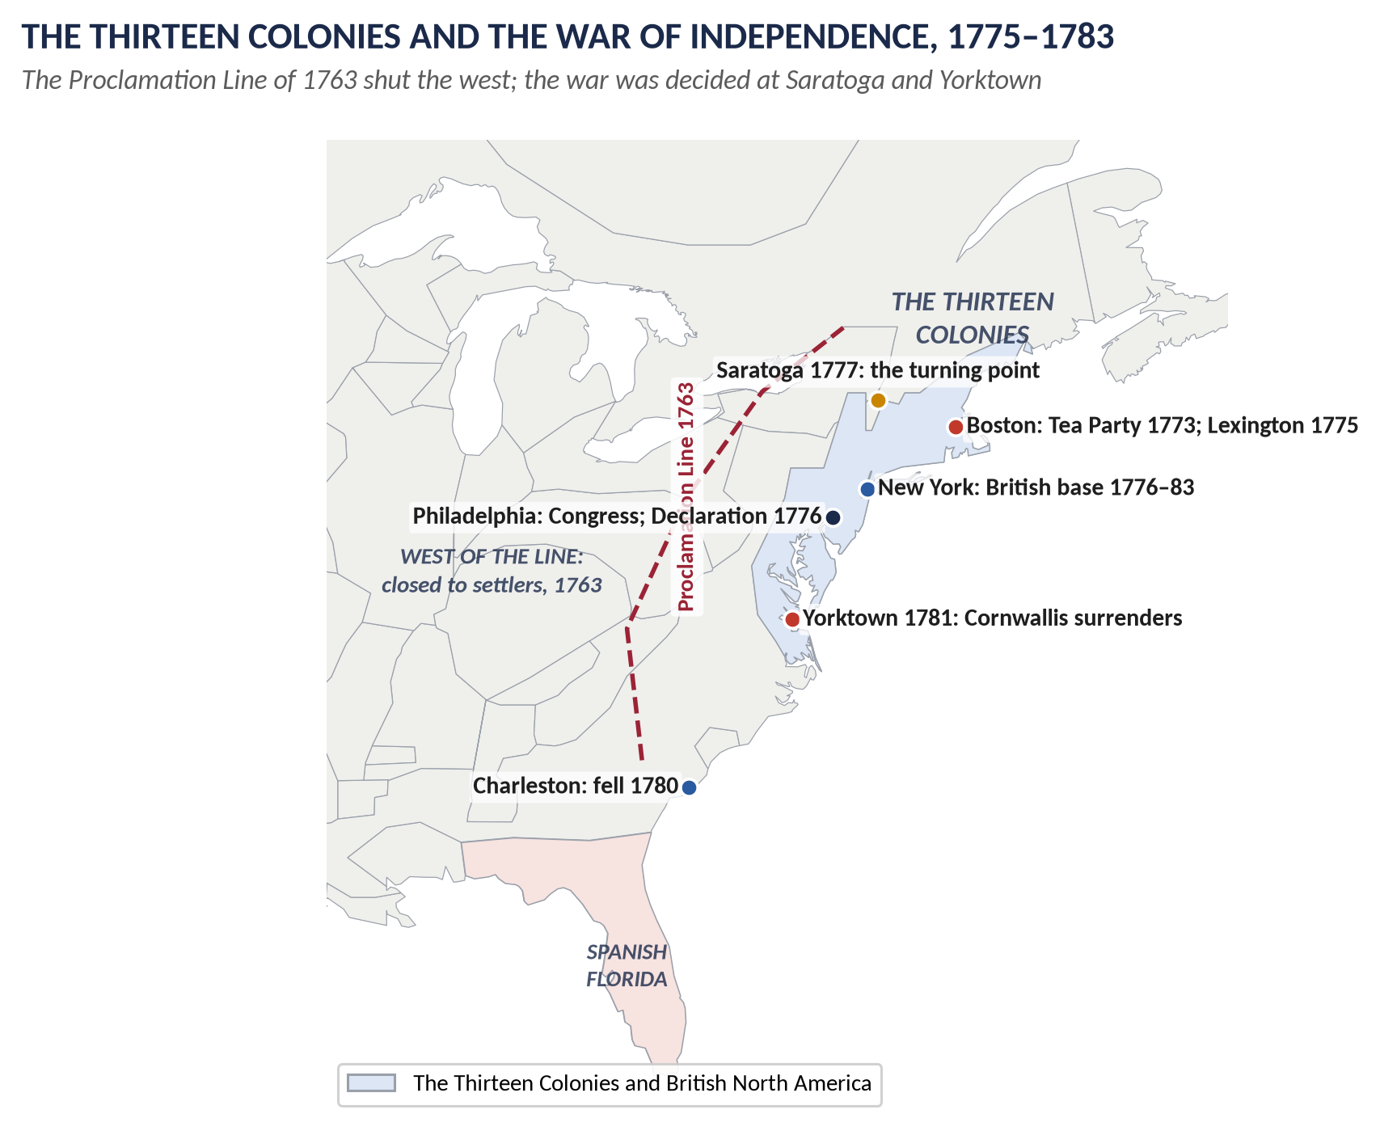
Figure 13 · The war that lost the first empire.

The debit side

(3) Territory and power
Thirteen colonies of some 2.5 million people — the most populous and fastest-growing part of the empire — were lost. It was the first great reverse to British expansion since the seventeenth century.

(4) Prestige and strategic position
Britain had fought without a single ally, faced the League of Armed Neutrality, lost Minorca, and endured a three-year siege of Gibraltar. For the only time in the century, the Royal Navy lost control of home and American waters at the critical moment.

(5) Money
The National Debt rose from about £133 million to roughly £240 million; the land tax stood at 4s in the pound; interest charges consumed a large share of revenue and made further war impossible for a decade.

(6) Politics at home and in Ireland
Lord North's ministry fell in 1782 and George III's system of personal management was discredited; Dunning's motion (1780) had already declared that "the influence of the Crown… ought to be diminished". In Ireland, the Volunteers exploited Britain's weakness to win legislative independence in 1782 — a problem that would run to 1801 and beyond.

The credit side

(7) Trade survived the political break
The colonies had been valued for their commerce, and the commerce continued. Anglo-American trade recovered within a few years and by the 1790s exceeded pre-war levels: Britain remained America's chief supplier and market. This vindicated Adam Smith, whose Wealth of Nations (1776) had argued that the colonial monopoly cost more than it earned.

(8) The rest of the empire was kept
Canada, the West Indies, Gibraltar and — decisively — India remained. Rodney's victory at the Saintes (1782) restored naval prestige and protected the sugar islands in the final peace.

(9) Reform at home
Defeat forced change: Burke's Economical Reform Act (1782) cut royal patronage; the India Act (1784) brought the East India Company under government supervision; and Pitt the Younger, prime minister from December 1783, rebuilt the finances with a new sinking fund and reduced duties.

(10) A different idea of empire
Britain learned that colonies of settlement could not be governed from London indefinitely. The Constitutional Act for Canada (1791) granted representative institutions; in the next century the Durham Report (1839) and responsible government followed the same logic, and eventually the Dominions and the Commonwealth (Topic 8).

(11) The swing to the East
With America gone, expansion turned towards India, the Pacific (Botany Bay, 1788) and later Africa. The "second British Empire" that resulted lasted far longer than the first.

(12) The balance
 | Short term (1783–1800) | Long term
Debit | Colonies, prestige, debt, political crisis, Ireland | A rival great power created in the USA
Credit | Trade recovered; empire elsewhere intact | Reform at home; self-government as an imperial principle; the eastern empire

(13) Conclusion
On the debit side Britain lost an empire of settlement, its military reputation and its financial margin, and was forced to concede to Ireland what it had denied to America. On the credit side it kept the trade without the cost of ruling, retained the rest of the empire, reformed its own government, and turned east to build a larger one. The debit was paid at once and in full; the credit accumulated over a generation. Contemporary Britain thought 1783 a catastrophe; by 1815 it looked like the price of a wider dominion.
WHY THIS ANSWER SCORES
The question's two named categories become the two halves of the answer, with a table that forces the comparison the examiner wants. Adam Smith, Dunning's motion and the Irish settlement give the analysis evidence beyond the battles.

Part Two — The Past MCQs, Solved
HOW TO USE THIS · The topic's objective questions, 2024–2026
Seven MCQs from the last three papers belong to Topic 2, with their printed options, the keyed answer and the reason.

CSS 2024 · MCQ 1
Who is the longest-serving British Prime Minister?
(A) Robert Walpole | (B) Margaret Thatcher | (C) James Callaghan | (D) None of these

REMEMBER · Answer: A. Robert Walpole
Walpole held office from 1721 to 1742 — twenty-one years, still the longest premiership in British history. Thatcher (1979–90) was the longest of the twentieth century.

CSS 2024 · MCQ 13
Who was the British monarch during the American Revolutionary War?
(A) George I | (B) George II | (C) George III | (D) None of these

REMEMBER · Answer: C. George III
George III reigned from 1760 to 1820 and was king throughout the American war (1775–83).

CSS 2025 · MCQ 3
What was the primary cause of the Jacobite rebellions?
(A) Religion | (B) Economics | (C) Nationalism | (D) None of these

REMEMBER · Answer: D. None of these — the central issue was the Stuart dynastic claim, intertwined with religion
The central issue was the Stuart dynastic claim — the belief that the rightful king had been deposed in 1688. Religion was bound up with it, but neither religion, economics nor nationalism alone is the primary cause, so the key is "None of these".

CSS 2025 · MCQ 4
Which issue most directly led to the American War of Independence?
(A) Slavery | (B) Taxation | (C) Trade | (D) None of these

REMEMBER · Answer: B. Taxation
Taxation without representation — the Sugar Act (1764), the Stamp Act (1765) and the Townshend duties (1767) — was the immediate issue, though the deeper quarrel was over Parliament's sovereignty.

CSS 2026 · MCQ 3
The Seven Years’ War established British dominance over:
(A) Dutch Indonesia | (B) Spanish Caribbean | (C) French North America | (D) None of these

REMEMBER · Answer: C. French North America
The Treaty of Paris (1763) gave Britain Canada and all French territory east of the Mississippi: French North America.

CSS 2026 · MCQ 4
Who was Prime Minister during the American Declaration of Independence?
(A) William Pitt the Younger | (B) Lord North | (C) Robert Walpole | (D) None of these

REMEMBER · Answer: B. Lord North
Lord North was prime minister from 1770 to 1782, and therefore at the Declaration of Independence on 4 July 1776.

CSS 2026 · MCQ 14
The American War of Independence ended with the:
(A) Treaty of Paris 1783 | (B) Treaty of Versailles 1783 | (C) Treaty of London 1783 | (D) None of these

REMEMBER · Answer: A. Treaty of Paris 1783
The Treaty of Paris of 1783 recognised American independence. (The Treaty of Paris of 1763 had ended the Seven Years' War.)

Part Three — Five Predicted Questions, with Outlines
NOTE · Why these five
They come from the topic's blind spots (Master Anatomy, Part 3.6 and the T2 dossier): the Old Colonial System, the Jacobites as a full question, George III's politics, and the causes of the American war on their own.

Predicted 1 · "Explain the Old Colonial System. Why did it break down in America?"
- Thesis: a mercantilist system that worked while it was loosely enforced, and collapsed when victory in 1763 made Britain enforce and tax it.
- Headings: (1) Mercantilist theory · (2) The Navigation Acts, 1651–1750 · (3) The slave trade and the sugar colonies · (4) "Salutary neglect" in practice · (5) 1763: enforcement, taxation and the Proclamation Line · (6) The constitutional collision · (7) Verdict — the system's success created its crisis.
- Figure: the triangular trade map; the flow diagram of the causes of the American war.

Predicted 2 · "Give an account of the Jacobite risings of 1715 and 1745. Why did they fail?"
- Thesis: both failed for the same three reasons — no English rising, no adequate French help, and the financial and naval strength of the Hanoverian state.
- Headings: (1) What Jacobitism was · (2) The Fifteen: causes, course, failure · (3) The Forty-Five: Glenfinnan to Derby · (4) Culloden and the repression · (5) Common causes of failure · (6) Significance for Scotland and for Britain.

Predicted 3 · "Assess the reign of George III to 1783. Did he try to subvert the constitution?"
- Thesis: no — he used powers the constitution gave him, but he used them badly, and the loss of America discredited the attempt.
- Headings: (1) The old Whig charge and Namier's answer · (2) The King's aims in 1760 · (3) Bute and the King's Friends · (4) Instability, 1760–70 · (5) Wilkes and public opinion · (6) North, America and Dunning's motion · (7) Verdict.

Predicted 4 · "What were the causes of the American War of Independence? Could Britain have avoided it?"
- Thesis: avoidable until 1774 — the constitutional collision was real but a federal compromise (Burke's or Chatham's) was available; the Coercive Acts closed the door.
- Headings: (1) The legacy of 1763 · (2) The tax measures, 1764–73 · (3) The constitutional question: sovereignty and virtual representation · (4) Ideology and colonial society · (5) Missed opportunities: 1766, 1770, 1775 · (6) Verdict.

Predicted 5 · "Evaluate Britain's role in the Atlantic slave trade and its abolition."
- Thesis: Britain was the largest carrier of the eighteenth century and the leading abolitionist of the nineteenth — and the second fact does not cancel the first.
- Headings: (1) The trade: scale, ports, the triangle, the asiento · (2) Its place in the colonial economy · (3) The abolition campaign, 1787–1807 · (4) The Williams–Drescher debate · (5) Emancipation 1833 and its limits (compensation, apprenticeship, indenture) · (6) Anti-slavery and empire after 1833 · (7) Verdict.

